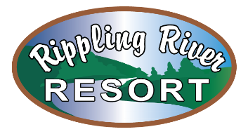
EMPLOYMENT OPPORTUNITY

Rippling River Resort Office Staff

The Role-
The incumbent is responsible for taking reservations, checking guests in and out of the campground and ensuring guests receive exemplary service. Position is approximately 10-20 hours per week, with the possibility of more hours during busy weeks.

-Responsibilities-
The incumbent is responsible for:
- Answering phones and taking reservations
-Processing online reservations
-Checking and answering the Resort email and voicemail
-Checking in guests upon arrival and checking out guests
-Helping stock the campground store and process store transactions
· Providing local information and campground area information
-Must be available on nights and weekends

-Minimum Qualifications-
· Must be a minimum of 18 years of age
· Must hold a valid Driver’s License
· Must be computer literate

-Education and/or Experience-
· Hospitality and/or Tourism experience an asset
· First Aid/CPR certified a plus

-Language Skills-
Ability to read, analyze and interpret general business periodicals, technical procedures, or governmental regulations. Ability to effectively respond to questions from managers, clients, customers, and the general public.

-Physical Requirements-
· Requires visual acuity and ability to hear to clearly communicate with managers, coworkers, guests and vendors
· Must be able to sit, stand and walk for extended periods of time
· Must be able to reach with arms and hands
· Must be able to lift and/or move up to 50 lbs.
· Must have finger to hand dexterity to be able to grip, grasp items or equipment

Job Type: Part-time
Salary: $13.00 /hour
Apply in person at Rippling River Resort, 4321 M-553, Marquette, Michigan 49855.

